# Avoiding Memory Errors

## The Issue

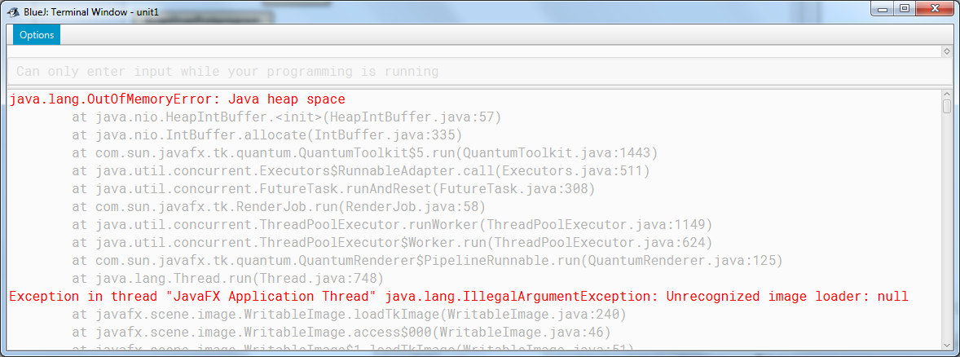You’re working on a large screen and/or doing lots of drawing on the console, and everything slows down and seems to hang up. Then you get a “Terminal Window” popping up with red errors in it that looks a bit like the one below.

## What’s Going On?

This is a sign that Java is running out of memory. It’s happening because of all the work that’s going on in the background to make things easier for you. The hsafx console code is refreshing your screen 60 times per second, so that you don’t have to worry about refreshing it yourself. If the console didn’t do this, your drawings would not appear automatically on the screen.

## The Easiest Solution: Work Small

Keep the console window small if you can. The smaller the screen, the less likely it is that you will see this problem.

## The Best Solution: Refresh the Screen Yourself

If you need a big screen, or if you’re getting errors even on a small screen, you will have to take control of the screen refreshing yourself. You do this by using the commands below.

**c.autoRefreshOff()**

This command turns off the auto-refresh system that is causing the memory errors. But now all your graphics output will not appear on the screen right away. Do this at the beginning of your program.

**c.refresh()**

This forces a single refresh of the screen. All the drawing you have done since the last time you called c.refresh() will now appear on the screen.

For the unit 1 programs, you should call c.refresh() before any c.sleep() or c.getChar() statement to make the screen refresh itself once before you pause. You may also need to call c.refresh() at the end of your program.

**c.autoRefreshOn()**

This turns the auto refresh system back on. You might need to do this temporarily if you are getting input from the user (see Unit 2), since it is the auto refresh system that makes the cursor appear and start blinking.